# Department of Computer Technology

### Vision of the Department

*To be a well-known centre for pursuing computer education through innovative pedagogy, value-based education and industry collaboration.*

### Mission of the Department

*To establish learning ambience for ushering in computer engineering professionals in core and multidisciplinary area by developing Problem- solving skills through emerging technologies****.***

## Session 2025-2026

**Mission:** To Make real life project related to computer vision

**Vision:** To Become Excellent in Computer vision

**Program Educational Objectives of the program (PEO):** (broad statements that describe the professional and career accomplishments)

|  |  |  |  |
| --- | --- | --- | --- |
| PEO1 | **Preparation** | **P: Preparation** | **Pep-CL abbreviation**  **pronounce as Pep-si-lL easy to recall** |
| PEO2 | **Core Competence** | **E: Environment (Learning Environment)** |
| PEO3 | **Breadth** | **P: Professionalism** |
| PEO4 | **Professionalism** | **C: Core Competence** |
| PEO5 | **Learning**  **Environment** | **L: Breadth (Learning in diverse areas)** |

**Program Outcomes (PO):** (statements that describe what a student should be able to do and know by the end of a program)

## Keywords of POs:

Engineering knowledge, Problem analysis, Design/development of solutions, Conduct Investigations of Complex Problems, Engineering Tool Usage, The Engineer and The World, Ethics, Individual and Collaborative Team work, Communication, Project Management and Finance, Life-Long Learning

**PSO Keywords:** Cutting edge technologies, Research

“I am an engineer, and I know how to apply engineering knowledge to investigate, analyse and design solutions to complex problems using tools for entire world following all ethics in a collaborative way with proper management skills throughout my life.” *to contribute to the development of cutting-edge technologies and Research*.

**Integrity:** I will adhere to the Laboratory Code of Conduct and ethics in its entirety.

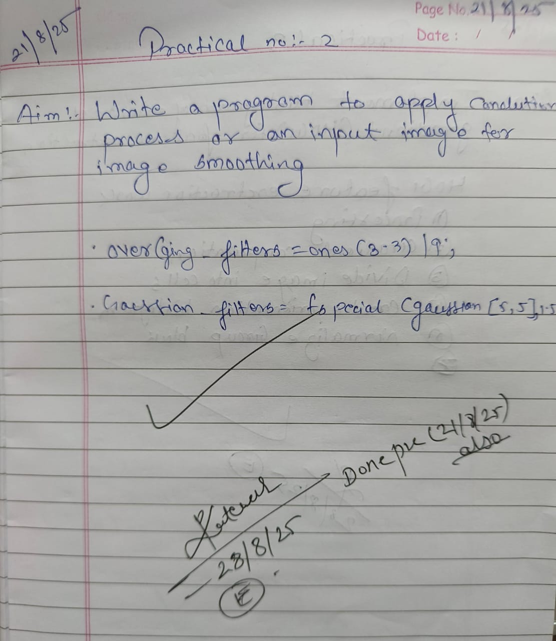

**Ganesh Pandile**

## Name and Signature of Student and Date

(Signature and Date in Handwritten)

# Department of Computer Technology

### Vision of the Department

*To be a well-known centre for pursuing computer education through innovative pedagogy, value-based education and industry collaboration.*

### Mission of the Department

*To establish learning ambience for ushering in computer engineering professionals in core and multidisciplinary area by developing Problem- solving skills through emerging technologies****.***

|  |  |  |  |
| --- | --- | --- | --- |
| **Session** | **2024-25 (ODD)** | **Course Name** | **Computer vision Lab** |
| **Semester** | **5** | **Course Code** | **CT** |
| **Roll No** | **46** | **Name of Student** | **Ganesh Pandile** |

|  |  |
| --- | --- |
| **Practical Number** | 2 |
| **Course Outcome** | Apply image enhancement and smoothing techniques to improve image quality for further analysis. |
| **Aim** | Write a Program to apply convolution processes on an input image for image smoothing. |
| **Problem Definition** |  |
| **Theory**  **(100 words)** | ***Convolution for Image Smoothing***  ***Convolution*** *is a process used in image processing to apply filters to images. In* ***image smoothing (blurring)****, convolution helps reduce noise and minor details by averaging pixel values with their neighbors.*  *This is done using a* ***kernel (filter matrix)****, like a 3x3 matrix, which slides over the image. Each output pixel is calculated as a weighted sum of the surrounding pixels defined by the kernel.* |
| **Procedure and Execution**  **(100 Words)** | Algorithm:   1. Start the program:   Initialize the environment by closing all figure windows and clearing the command window.   1. Read the image:   Load the input image (deer.jpg) from the specified file path using imread.   1. Convert image to double precision:   Use im2double() to convert the image to double format for accurate calculations.   1. Define smoothing filters:   Create a 3×3 averaging filter (not used in final convolution).  Create a 5×5 Gaussian filter with standard deviation 1.5 using fspecial.   1. Select the smoothing filter:   Assign the Gaussian filter as the active filter for convolution.   1. Apply 2D convolution:   Use conv2() to apply the smoothing filter on the Red channel of the image.  Use 'same' to ensure the output image size matches the input.   1. Display the original image:   Use imshow() to show the original image in the first subplot.   1. Display the smoothed image:   Show the result of the convolution (smoothed red channel) in the second subplot.   1. End the program:   The program finishes after displaying both images. |
| Code:  close all;  clc;  original_image = imread("C:\Users\student\Desktop\CT_46_CV\deer.jpg");  original_image_double = im2double(original_image);  averaging_filter = ones(3,3) / 9;  gaussian_filter = fspecial('gaussian',[5 5],1.5);  smoothing_filter = gaussian_filter;  smoothed_image = conv2(original_image_double(:,:,1),smoothing_filter,'same');  figure;  subplot(1,2,1);  imshow(original_image);  title('Original Image');  subplot(1,2,2);  imshow(smoothed_image);  title('Smoothed Image (Convolution)'); |
| Output: |
| **Output Analysis** | The code reads a color image and applies Gaussian smoothing using 2D convolution.  Only the Red channel of the image is processed.  The output shows:   * Original Image (in color) * Smoothed Image (in grayscale, blurred)   Effect: Reduces sharpness and noise; details appear softer.  Good for noise reduction and pre-processing. |
| **Link of student Github profile where lab assignment has** |  |

# Department of Computer Technology

### Vision of the Department

*To be a well-known centre for pursuing computer education through innovative pedagogy, value-based education and industry collaboration.*

### Mission of the Department

*To establish learning ambience for ushering in computer engineering professionals in core and multidisciplinary area by developing Problem- solving skills through emerging technologies****.***

|  |  |
| --- | --- |
| been uploaded |  |
| Conclusion | Successfully Implement image enhancement and smoothing techniques to improve image quality. |
| Plag Report (Similarity index < 12%) |  |
| Date | 29/08/2025 |